B of key Orange Logic's GTM team and account rep territories:

CRO: Brendan Wright

EVP of Growth: Mike Centioli
Head of Alliance & Partnership: Adam LaPorta

Global Head of Sales: Derek Coles

Enterprise Account Executives:
Alex Harris - Midwest to West-ish: MN, WI, IA, IL, MO, KS, CO, UT, NM, TX, OK, AR, LA
Brian Bednarek - owns all of Retail / Apprael in North America
Eric Davis - Midwest to Southeast : MI, IN, OH, KY, WV, TN, NC, SC, MS, AL, GA, FL
Garrett Sayer - owns all of Media and Entertainment in North America
Rebecca Schmidt - Northeast: ME, VT, NH, MA, CT, RI, NY, PA, NJ, DE, MD, DC, VA
Shannon Franzen - West, South and North - AK, WA, OR, CA, AZ, NV, ID, MT, WY, ND, SD, NE

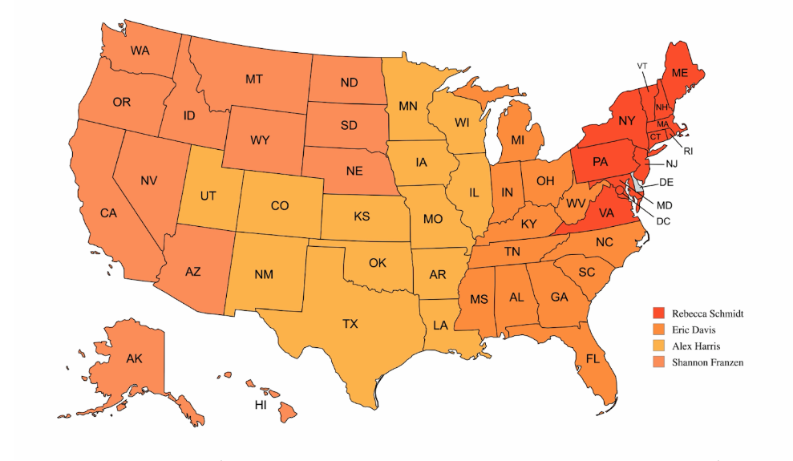

Mid Market Account Executives:
Jaryd Jean-Felix - North America: all accounts under $500M / Annual
Damon Brooks - North America: All accounts under $500M / Annual

EMEA Enterprise Sales Reps/Regions:
Florian Delille
Samantha Campton

Customer Success Team (12 CSMs)
Phillip Gulbrandsen: Head of CSM, oversees the Global Customer Success & Account Management function
Hope Powels: Manager in the Customer Success Org

Looking forward to connecting Friday! I have also included Mike C in our meeting.

Best,

Adam

